Freedom Fone

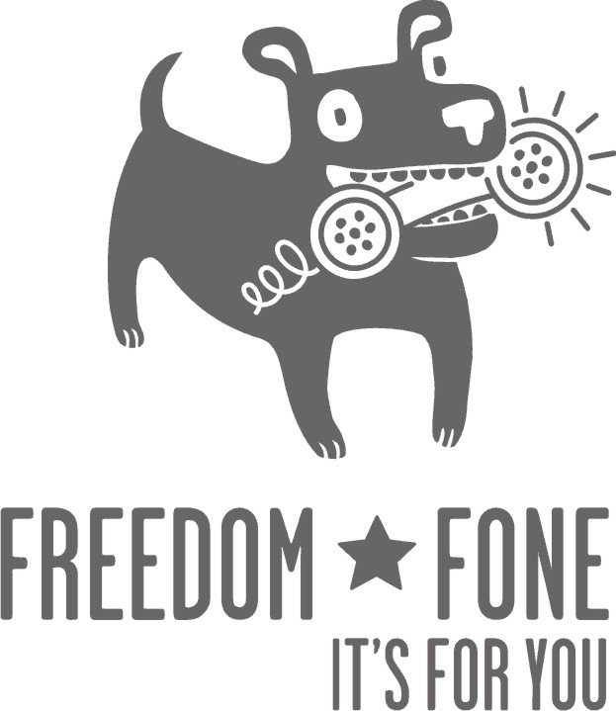
Quick Start Guide
Freedom Fone Pictus Lupinus 1.5.2

March 2010
Author: Kubatana.net
Version 1.5.2

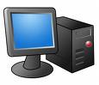  Stage 1: Installing the software  Note:  Estimated time for installation is 15 minutes | Please note that the Freedom Fone v1.5 DVD will overwrite all data currently on the computer.  - Insert the Freedom Fone DVD and restart the computer.  - Ensure that the computer’s BIOS settings enable the computer to boot from the DVD. If the computer is not currently set to do this, restart the computer and look for the prompt to modify the BIOS settings and set the primary boot device to the CD/DVD player.  - When prompted, type install to begin the installation. Note that Freedom Fone will not work properly as a live CD.  - Step 1: Select the language you prefer for installation. Once selected, click “forward”.  - Step 2: Select the city in which you are running the server. Once selected, click “forward”.  - Step 3: Select keyboard layout. Check this setting by typing the following characters into the box provided: ~, @, |, / and ensuring the symbols displayed are correct. Once complete, click “forward”.  - Step 4: Prepare disk space. Select “Guided – use entire disk” and then click “forward”.  - Step 5: When it asks “who are you”, enter “lupinus”. When it asks the password, enter “lupinus” twice and then click “forward”.  - Step 6: Confirm installation details.  - Step 7 of 7: Click install. Once installation is complete, click “restart now”.  - When prompted remove the DVD, close the tray and click “enter”.
Stage 2:  Checking the time | Date and time are important as they are used to log calls and manage polls. Make sure your settings are correct.  - The computer should restart after the previous stage.  - For the computer login, the username and password is “lupinus”.  - Check that the date and time displayed in the top right hand corner of your screen is correct for your location.  - If you need to adjust the date and time, right click over the date and time icon in the top right hand corner.  - Select “adjust date and time”.  - To unlock for any time adjustments, the password is “lupinus”.
Stage 3:  Connecting to the internet (Optional) | For those of you who are able and wish to connect to the internet, this is how you manually configure your connection.  - Don’t forget to have your ethernet cable plugged in!  - From the menus at the top of the screen, select System/Administration/Network.  - Click “unlock”.  - Enter the password, “lupines”.  - Click on the “wired connection”.  - Click on “properties”.  - Unselect, “enable roaming mode”.  - Depending on how your network is administered either select, “automatic configuration (DHCP) or select the “static IP address” from the configuration drop down list.  - If you select “static IP address”, ask your network administrator for an IP address, subnet mask and gateway address. Click DNS under the network settings and add DNS servers, as provided by your network administrator.  - Restart your computer for the networking settings to take effect.
Stage 4:  Familiarise yourself with the Freedom Fone user interface (Optional) | Double click on the Freedom Fone shortcut on the desktop and then take a look at the different Freedom Fone menu options.  - Under the main Freedom Fone menu, use the Functionality option to read about Polls, the Leave-a-message facility, Voice Menus, Callbacks (this function coming in Version 2) and Dashboard features.  - Take a look at the other menu options and then move on to Stage 5 below.
  Stage 5:  Getting the SIM card ready for use | For each SIM card you want to use with Freedom Fone, do the following:  - Ensure that the SIM card is activated.  - If you have a pre-paid SIM card, ensure that it is topped up with airtime and that it meets the pay-as-you-go operational requirements specific to your country.  - Insert the SIM card in a mobile phone and ensure the settings are modified to deactivate future pin requests, i.e. so that no pin is requested in the future.  - Ensure there is good network coverage in your work area.  - Remove the SIM card from the mobile phone and place it in the telephony device i.e. the MobiGater or Voice Blue Lite.  - Make a note of the IMEI code associated with the MobiGater or Voice Blue Lite module bay, into which the SIM card is inserted. Make a note of the phone number associated with the SIM card. This information will be useful when you test the system later.
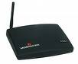  Stage 6:  Connecting computer to the Mobigater | If using more than one MobiGater, please connect one device at a time and test before adding any further devices.  - If it is on, switch the Freedom Fone server off before you add each MobiGater.  - Connect the MobiGater to the computer via a USB cable.  - Connect the MobiGater to the power.  - Switch the computer on.  - If all is correct, the LEDs on the MobiGater will light up as follows: the LEDs under the power and USB icons will both light up red. The LED under the mobile phone icon will flicker red roughly every four seconds, as the SIM card polls the nearest mobile network tower.  - If the Freedom Fone user interface is not already open, click on the Freedom Fone shortcut on the desktop.  - Select “Dashboard/GSM channels” from the Freedom Fone menu.  - The MobiGater you’ve just connected should be displayed – check the IMEI number and compare it with the notes you took in Stage 5.
Stage 7a:  Testing  telephony device  with leave-a  message  function | The first MobiGater connected to the Freedom Fone server will, by default, connect to the Leave-a-message voice menu (IVR).  - Click “Dashboard/Call data records” from the Freedom Fone menu.  - The call data records page will be empty if there have been no previous calls to this system to date. You can click on the “Refresh button” at any time to view information associated with completed calls or calls in progress.  - Call the mobile number of the first MobiGater connected.  - If you have not yet modified the Leave-a-message voice menu, using the Freedom Fone Leave-a-message/IVR menu screen, you will hear the Freedom Fone default voice menu.  - Listen to the prompts and leave a message after the beep.  - If you are NOT using a registered copy of Cepestral, you will have an automated voice offering reminders to license the text-to-speech voice, in between the IVR prompts.  Read the Troubleshooting Guide in the Documentation folder on your desktop to deal with the Cepstral nag! Upload your own audio files as soon as possible to avoid using the unlicensed text-to-speech voice.  - If you can successfully leave a voice message, select “Leave-a-message/Inbox” from the Freedom Fone menu to edit details associated with the voice message and to listen to it. Click the “Refresh button” if you do not see your voice message.  - If you CANNOT leave a voice message, because the selections you are making using your phone’s key pad, are being ignored, see the Troubleshooting Guide in the Documentation folder on your desktop.
Stage 7b:  Testing  telephony  device  with SMS  function | Check to see if the SIM in the MobiGater is receiving ordinary text messages.  - Send a message to the mobile number associated with the SIM card in the MobiGater.  - Select “Poll/Other SMS” from the Freedom Fone menu to view the SMS messages that have been received.  - Click the “Refresh button” repeatedly until your message can be seen.  - If your mobile network’s message centre is operating efficiently you should see your message appear within seconds.
Stage 7c:  Testing  telephony device  with poll  function | Set up a test poll and experiment.  - Select “Poll/Manage polls” from the Freedom Fone menu.  - Create a new poll, put in a question, give the poll a code, and add 2 or more options.  - Send test SMS messages to your mobile number. Remember each SMS must start with the poll’s code as its first word, followed by one of the allowed options.  - Click the “Refresh button” on the “Poll/Manage poll” page and watch the votes add up.  - Click the poll question for more detailed information on the votes coming in.
Stage 7d:  Modify the leave-a-message IVR | Edit the Leave-a-Message IVR by modifying the text to suit your needs, or create and upload your own voice files.  - Select “Leave-a-message/IVR Menu” from the Freedom Fone menu.  - If you create audio files for this menu, make sure to sample them as mono, 8Khz files less than 10MB in size.  - Either WAV or MP3 files can be used.
Stage 8:  Adding more Mobigaters (Optional) | - If you want to add more MobiGaters, shut down the computer again and connect the next telephony device as per the steps in Stage 6.  - Please note that if more than one telephony device is connected, by default the:  - first and third devices are connected to the “Leave-a-Message” service.  - second telephony device is connected to the default voice menu – created and set using the Freedom Fone Voice menus/voice menus screen.  - If you want to modify these default associations, read the Troubleshooting Guide in the Documentation folder on your desktop.
Stage 9a:  Create your own  voice menu  options | Upload the Menu Options page, to be used in your Voice Menus.  - Select “Voice menus/Menu options” from the Freedom Fone menu.  - Click “Upload new” to add an audio file that will be played when a caller makes a selection from your voice menu.  - Give the audio file a title and browse the server for the audio file (mp3 or wav) that you want to upload.  - Click the “Save” button and you will be returned to the Menu Options page where an entry for your audio file should be displayed.  - Please note that audio files should be created as mono, 8Khz files, less than 10MB in size.  - Either WAV or MP3 files can be used.  - Select “Voice menus/Voice menus” from the Freedom Fone menu.  - Click “Create new”.
Stage 9b:  Create your own  voice menus | Create your own Voice Menus.  - Select “Voice menus/Voice menus” from the Freedom Fone menu.  - Click “Create new”.  - Give the new IVR a name.  - If you have licensed a copy of Cepstral, you can experiment with text-to-speech by using text instead of audio files for your Welcome, Instructions etc. messages for your menu.  - For all audio file prompts, please note that files should be created as mono, 8Khz files less, than 10MB in size.  - Either WAV or MP3 files can be used.  - In the Menu options section of this screen either use:  - the drop down menus next to each valid menu entry for your voice menu, and select the audio file that should be played when a caller selects that option, or  - select the Leave-a-message component to direct callers to your Leave-a-Message IVR when they select this menu option.  - Once you have saved your menu, you can return in edit mode and use the flash audio player to listen to your prompts and menu option files.

